HEAL ROBOT
Pick-and-Place with Three IK Methods
Comparative simulation report | Mink, damped least-squares (DLS-IK), and constrained QP-IK
BASELINE  75 / 75  successful trials | WIDE STRESS  41 / 45  successful trials | QP-IK STRESS  11 / 15  successful trials

Abstract
A simulated HEAL arm with a Robotiq 2F-85 gripper was used to perform cube pick-and-place on a table with a tray target. Three implementations were evaluated: Mink inverse kinematics with DAQP, a damped least-squares Cartesian velocity controller, and a constrained quadratic-programming (QP) controller. The task sequence approached the cube, descended, closed the gripper, verified a lift, carried the object above the tray, lowered it, released it, and retreated.
Main findings
- In the baseline evaluation, all three methods completed 25 of 25 episodes (100% each).
- In the wider stress test, Mink and DLS-IK completed 15 of 15 episodes; QP-IK completed 11 of 15 (73.3%).
- A replayed QP-IK failure (Episode 15, seed 12014) had no detected finger-pad contact and moved the cube 0.0422 m during gripper closure; the controller correctly stopped before lifting.
Aim and scope
The purpose was to integrate the end-to-end task, compare complete IK/control implementations under repeatable initial-condition changes, and document an observed failure. These are simulation results; they do not establish real-robot performance or a solver-only ranking.
Evidence basis: saved episode CSV summaries and logs from the project, plus the MuJoCo screenshot and replay log for QP-IK Episode 15.

1. Scene Design and Task Waypoints
The scene was arranged with the table in front of the robot while keeping the robot in its original orientation. This avoided an unnecessary robot-base rotation: the target positions were selected to be reachable from the existing orientation.
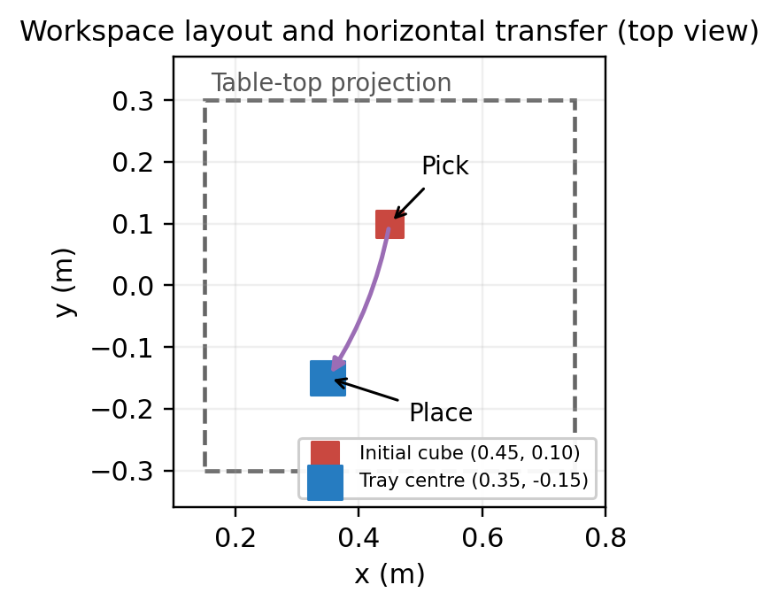
Figure 1. Top-view projection of the cube pick point and tray centre on the table. Arrows indicate the horizontal transfer; vertical lift and lowering are not represented in this projection.
Scene reference coordinates
Entity / parameter | Position or value | Role
Table body | [0.45, 0.00, 0.10] m | Front-table work surface
Cube initial centre | [0.45, 0.10, 0.225] m | 50 mm cube; nominal start
Tray reference centre | [0.35, -0.15, 0.205] m | Destination region
Cube mass | 0.050 kg | Stress-test scene configuration
Nominal table top | z = 0.20 m | Inferred from table body height and 0.10 m half-height

End-effector Cartesian targets
Waypoint | Target (x, y, z) m | Purpose
Pre-grasp | (0.45, 0.10, 0.45) | Approach above cube
Grasp | (0.45, 0.10, 0.36) | Descend and close gripper
Lift / carry height | (0.45, 0.10, 0.48) | Raise cube for clearance
Tray hover | (0.35, -0.15, 0.48) | Move across above tray
Place target | (0.35, -0.15, 0.375) | Lower for release

Trajectory rule: lift vertically first, carry horizontally at clearance height, descend into the tray, release, then retreat vertically. The separated phases reduced the earlier tendency to drag the cube into a tray boundary.

2. IK Implementations and Quantitative Results
Controller summary
Method | Implementation in the project | Comparison note
Mink | Mink FrameTask solves IK with DAQP; the resulting joint configurations are interpolated for motion. | Joint-space interpolation after IK targets are computed.
DLS-IK | Damped least-squares Jacobian maps Cartesian position/orientation error to joint velocity; torque-limited PD tracks joint references. | Cartesian velocity tracking with damping.
QP-IK | Projected accelerated-gradient QP with joint-speed and one-step joint-position bounds; torque-limited PD tracks the result. | Explicit joint and speed bounds in the QP calculation.

The scripts therefore compare three complete implementations, not only three isolated numerical solvers: Mink uses joint-space interpolation between solved configurations, while DLS-IK and QP-IK use Cartesian velocity tracking.
Episode results
Test condition | Mink | DLS-IK | QP-IK
Baseline: 25 episodes each | 25/25 (100%) | 25/25 (100%) | 25/25 (100%)
Wide stress: 15 episodes each | 15/15 (100%) | 15/15 (100%) | 11/15 (73.3%)
Wide stress failures | 0 | 0 | 4 (episodes 7, 8, 13, 15)

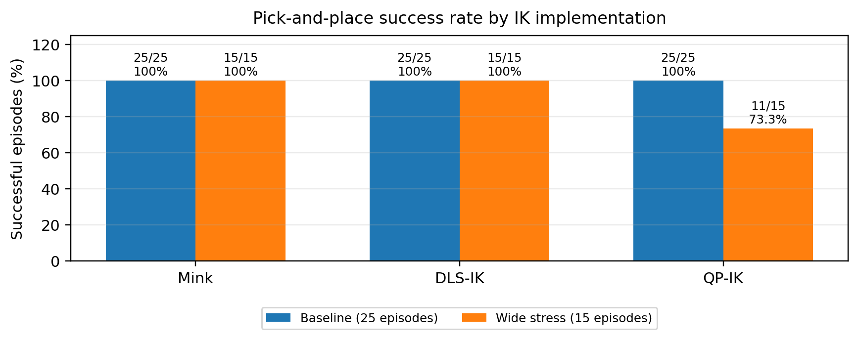
Figure 2. End-to-end success rate. “Success” requires the script’s task-success result, with lift and placement verification reported in the episode outputs.
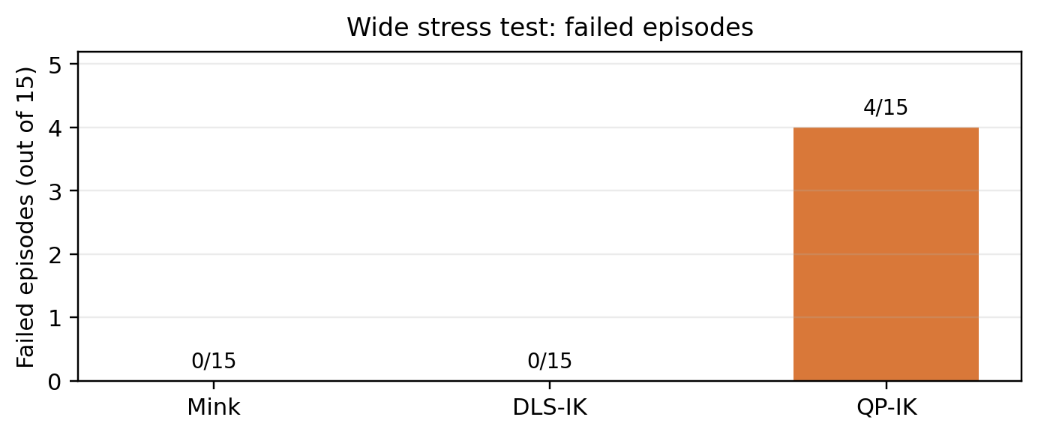
Figure 3. Failed episodes in the 15-episode wide stress test.
How the stress test varied conditions
The baseline sampled cube x/y offsets of ±0.02 m from the nominal start. The wide stress test sampled offsets of ±0.12 m. For each episode, identical offsets were used across methods, and the PREGRASP, GRASP, and LIFT x/y targets were shifted with the cube. This is a matched-start stress test, but it is not a fixed-target robustness test because grasp targets followed the randomized cube.

3. Failure Analysis: QP-IK Episode 15
The wider stress test produced four QP-IK episodes without verified success. Episode 15 (seed 12014) was replayed in the visible MuJoCo viewer and logged separately for diagnosis.
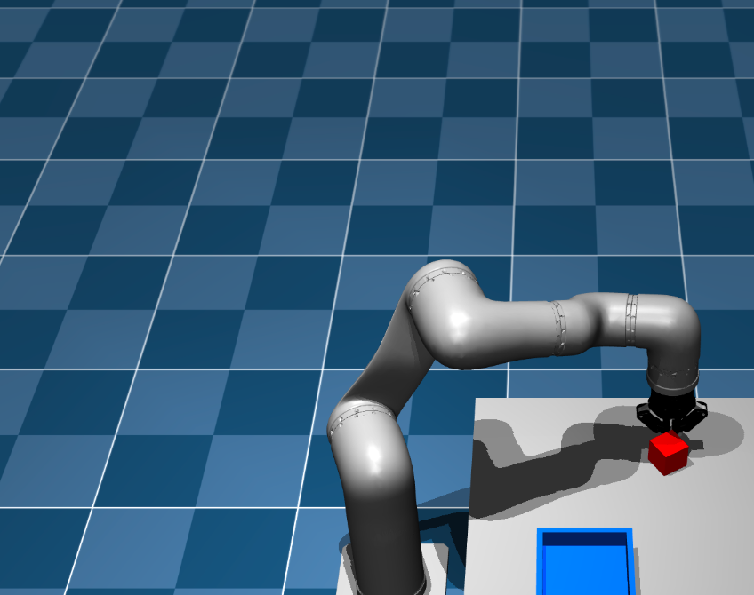
Figure 4. MuJoCo replay screenshot for QP-IK Episode 15. The cube remains on the table near the gripper; the paired log identifies the failed stage as grasping.
Measured evidence
Metric | Episode 15 result
Initial cube centre | [0.5037, 0.1725, 0.225] m
Final cube centre | [0.5034, 0.1303, 0.2244] m
Detected finger-pad contact | None
Horizontal displacement during closure | 0.0422 m (4.22 cm)
Vertical rise | -0.0006 m
Lift / placement verification | False / False
Decision | Grasp rejected; stopped before lift

Interpretation and corrective action
The logged controller reached the grasp-height phase, but neither finger pad was detected in contact. Cube displacement during closure was 4.22 cm, with essentially no upward motion. The most plausible interpretation is a grasp-alignment miss: the gripper closed off-centre and pushed the cube laterally. The data support this explanation, although the log alone does not establish a unique mechanical cause.
- Refine grasp pose alignment for larger cube offsets; evaluate the gripper’s contact geometry and approach orientation.
- Require bilateral pad contact and a small cube-motion threshold before authorizing the lift.
- Replay the identical start after the adjustment, then rerun the same seed set to determine whether the failure is corrected.
Evidence files: results/qp_failure_replay_ep15.log; results/heal_wide_stress_logs_15/qpik_ep15_seed12014.log; results/qp_failure_episode15.png; results/qp_failure_episode15_analysis.md.

4. Discussion, Limitations, and Conclusion
Discussion
The baseline run had no observed failures for any method (75/75 total). Under the wider starting-position perturbation, Mink and DLS-IK remained at 15/15 successes, while QP-IK succeeded in 11/15 trials. In this tested configuration, QP-IK was more sensitive to the wider perturbations. The observed failures occurred before lift verification, so they are grasp-acquisition failures rather than confirmed carry or release failures.
Limitations
- Sample sizes were 25 episodes per method in the baseline and 15 per method in the wide stress test. The wide test is useful diagnostic evidence, but it is not a comprehensive statistical evaluation.
- Grasp targets moved with cube x/y offsets; therefore the stress test does not evaluate performance against a fixed grasp target or complete perception uncertainty.
- Mink, DLS-IK and QP-IK use different trajectory/controller architectures. Wall runtime and success differences reflect the overall scripts as well as the IK method.
- Only one failed episode is presented in visual detail here. Episodes 7, 8 and 13 also failed in the QP-IK wide test and should remain in the failure logs for future diagnosis.
Reproducibility and saved artifacts
Artifact | Project location
Baseline episode data | results/heal_batch_episodes_25.csv
Wide stress data | results/heal_wide_stress_episodes_15.csv
Aggregate result summary | results/heal_evaluation_summary.md
Comparison plots | plots/heal_success_rate_comparison.png; plots/heal_runtime_comparison.png; plots/heal_placement_accuracy.png
QP Episode 15 replay / analysis | results/qp_failure_replay_ep15.log; results/qp_failure_episode15_analysis.md; results/qp_failure_episode15.png

Conclusion
A complete simulated HEAL pick-and-place sequence was demonstrated using Mink, DLS-IK, and QP-IK. The controlled baseline produced 100% success for all three implementations; a wider cube-position stress test exposed four QP-IK grasp failures. The logs show that the key corrective direction is better grasp alignment and contact validation before lift. Further testing should use independent fixed-target perturbations, repeated trials, and common timing definitions before drawing broader conclusions about solver robustness.
Software references
MuJoCo documentation: https://mujoco.readthedocs.io/en/stable/
Mink inverse-kinematics library: https://github.com/kevinzakka/mink

Table Design and Workspace Justification
The HEAL MuJoCo table dimensions are derived from the table-box geometry in the simulation scene.
Parameter | Scene value | Design relevance
Table length | 0.600 m | Extent along world X
Table width | 0.600 m | Extent along world Y
Tabletop thickness | 0.200 m | Thickness of the box geometry
Top-surface elevation | 0.200 m | Cube support surface
X limits | 0.150 to 0.750 m | Geometric tabletop limits
Y limits | -0.300 to 0.300 m | Geometric tabletop limits
The tabletop footprint defines the region available for cube starts and placement. Randomized starts should stay away from the edges. Workspace reachability must be assessed alongside collision-aware IK motion; the workspace plot alone does not guarantee safe motion.

